**Karan Arora**  **R.L. Institute M: 9416974837**

**Max Time : 1 hr** **Class = 10th Science Test**  **Max Marks : 25**

**ELECTRICITY CODE : A**

1. Define current. Give its SI unit. [ 1 ]
2. Should the resistance of a voltmeter be low or high? Give reason. [ 1 ]
3. Why is resistance less than when resistors are joined in parallel? [ 1 ]
4. A current of 0.5 A is drawn by a filament of an electric bulb for 10 minutes. Find the amount of electric charge that flows through any point of the circuit. [ 1 ]
5. Define 1 Ampere? [ 1 ]
6. Why does the cord of an electric oven not glow while its heating element does? [ 2 ]
7. An electric bulb of resistance 400 Ω, draws a current of 0.5 A. Calculate the power of the bulb and the potential difference at its ends. [ 2 ]
8. What should be the length of a nichrome wire of resistance 4.5 Ω, if the length of a similar wire is 60 cm and resistance 2.5 Ω? [ 2 ]
9. Carefully study the circuit diagram shown in figure and calculate the value of ‘x’. [ 3 ]

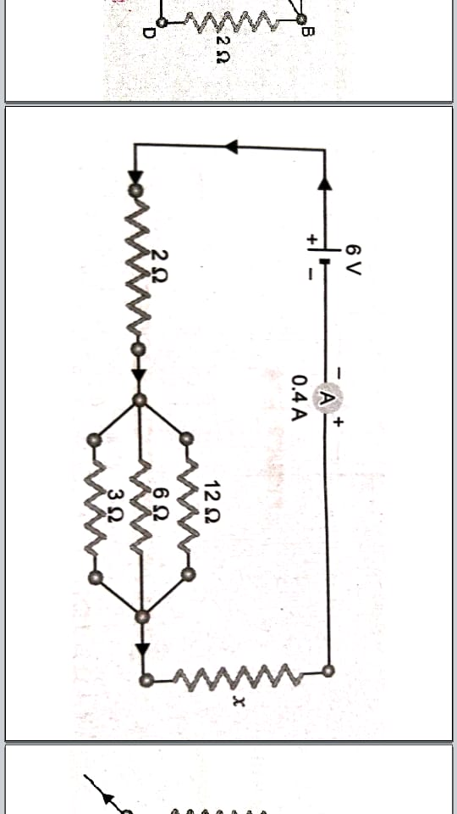

1. Explain the following : [ 3 ]
2. Why are the conductors of electric heating devices, such as bread-toasters and electric irons, made of an alloys rather than a pure metal?
3. How does the resistance of a wire vary with its area of cross section?
4. A copper wire has diameter 0.5 mm and resistivity of 1.6 x 10 – 8 Ω m. What will be the length of these wire to make its resistance 10 Ω. How much does the resistance change if the diameter is doubled? [ 3 ]
5. (A) For the given circuit diagram calculate : [ 5 ]

|  |
| --- |
|  |

1. The current through each resistor
2. The total current in the circuit.
3. The total effective resistance of the circuit.

(B) A torch bulb is rated 3 V and 600 mA. Calculate its resistance if it is lighted for 4 hours.

**Karan Arora**  **R.L. Institute M: 9416974837**

**Max Time : 1 hr** **Class = 10th Science Test**  **Max Marks : 25**

**ELECTRICITY CODE : B**

1. Define 1 Ampere? [ 1 ]
2. Define current. Give its SI unit. [ 1 ]
3. A current of 0.5 A is drawn by a filament of an electric bulb for 10 minutes. Find the amount of electric charge that flows through any point of the circuit. [ 1 ]
4. Should the resistance of a voltmeter be low or high? Give reason. [ 1 ]
5. Why is resistance less than when resistors are joined in parallel? [ 1 ]
6. What should be the length of a nichrome wire of resistance 4.5 Ω, if the length of a similar wire is 60 cm and resistance 2.5 Ω? [ 2 ]
7. An electric bulb of resistance 400 Ω, draws a current of 0.5 A. Calculate the power of the bulb and the potential difference at its ends. [ 2 ]
8. Why does the cord of an electric oven not glow while its heating element does? [ 2 ]
9. A copper wire has diameter 0.5 mm and resistivity of 1.6 x 10 – 8 Ω m. What will be the length of these wire to make its resistance 10 Ω. How much does the resistance change if the diameter is doubled? [ 3 ]
10. Explain the following : [ 3 ]
11. Why are the conductors of electric heating devices, such as bread-toasters and electric irons, made of an alloys rather than a pure metal?
12. How does the resistance of a wire vary with its area of cross section?
13. Carefully study the circuit diagram shown in figure and calculate the value of ‘x’. [ 3 ]



1. (A) For the given circuit diagram calculate : [ 5 ]

|  |
| --- |
|  |

1. The current through each resistor
2. The total current in the circuit.
3. The total effective resistance of the circuit.

(B) A torch bulb is rated 3 V and 600 mA. Calculate its resistance if it is lighted for 4 hours.